**WS15-ASSOCIATIONS-AGGREGATION**

**DATE: 07th december 2021**

**14 CORREA RUIZ KERLY YADIRA**

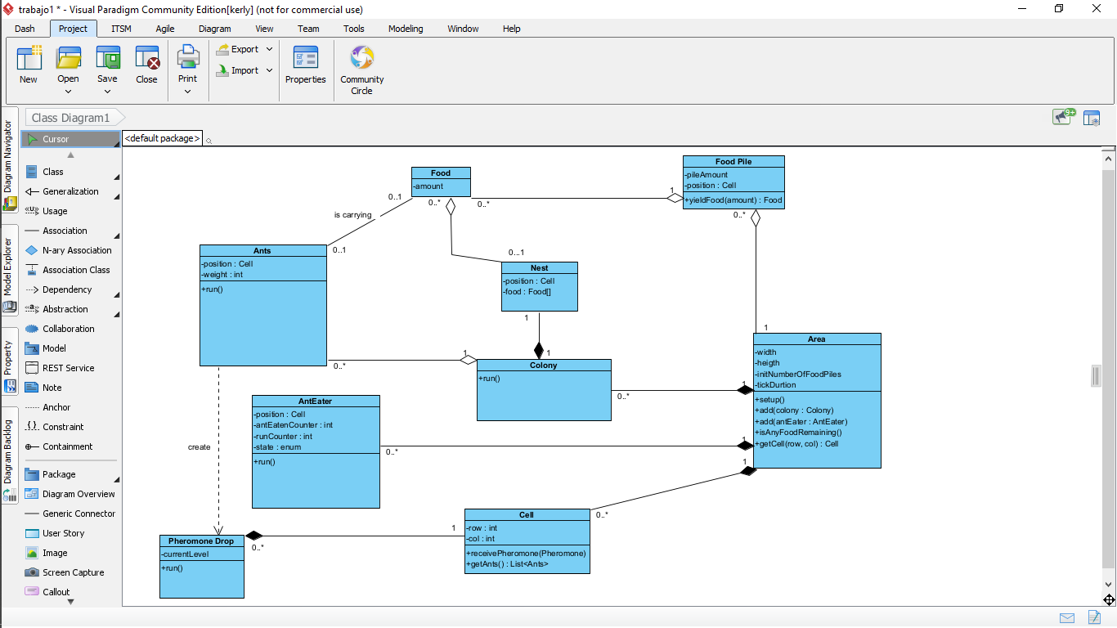

Inspector: Cruz Darling

classes: 9.5/10 Ants is in plural

relationships: 9.5/10

 falta int

1. Colony-Ant 1/1
2. Area-AntEater 1/1 (Cell-AntEater)
3. Area-Cell 1/1
4. Colony-Nest 0.5/1   (upside down)
5. FoodPile-Food 0.5/1   (upside down)
6. Ant-Food 1/1
7. Cell-PheromoneDrop 1/1      (upside down)
8. Area-Colony 1/1
9. Area-FoodPile 0.5/1    (upside down)
10. Simulator-Area 1/1
11. Ant-Pheromone           1/1       (dependency)

       TOTAL                              9.5/11

**15 CRUZ PANTOJA DARLING MICAELA**

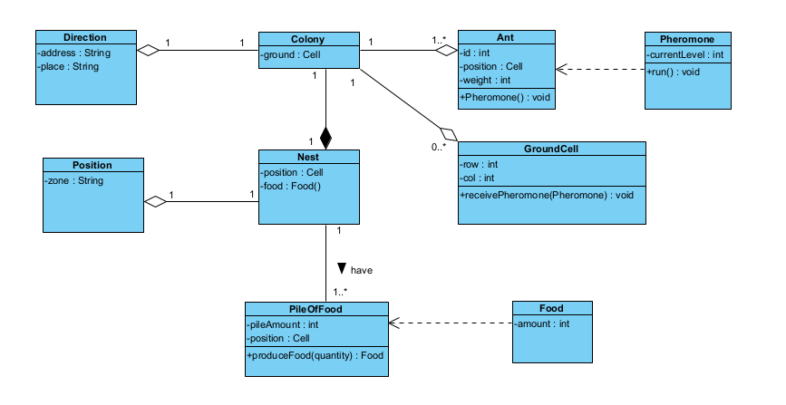  
Inspector: De La Cruz Alejandro

classes: 9/10 (falta una clase )

relationships: 8/10

Colony-Ant 1/1

Area-AntEater 1/1 (Cell-AntEater)

Area-Cell 1/1

Colony-Nest 1/1

FoodPile-Food 1/1

Ant-Food 0/1

Cell-PheromoneDrop  1/1

Area-Colony 1/1

Area-FoodPile 0/1

Simulator-Area 1/1